**Task 1**

1. Run any commands in the shell script

ls -lrt

free -m

touch test.txt

mkdir d1

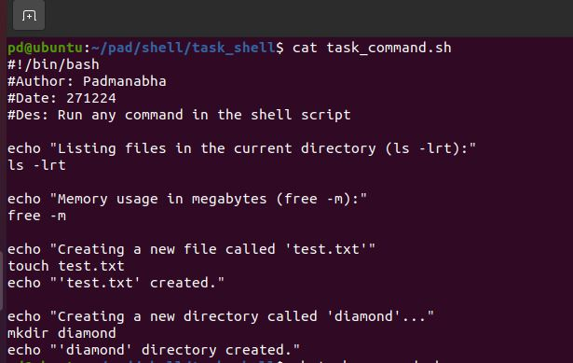

O/p

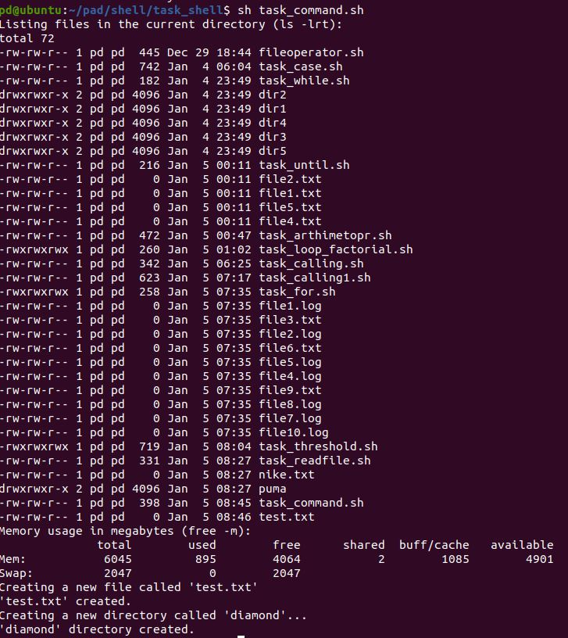

2. use read command twice to create the file and to create the dir

read filename

read dirname

.... $filename

.....$dirname

